Air Quality Prediction System using Machine Learning

Project Id: 15

Name : Priyanshi (Team Leader)
Class Roll Number:13
University Roll Number : 2028468
Section and Group: Q(G1)

Name : Taniya
Class Roll Number:18
University Roll Number : 2028510
Section and Group: Q(G1)

Name : Ananya Singhal
Class Roll Number:29
University Roll Number : 2028639
Section and Group: Q(G1)

- Problem Description 3
- Architecture 4
- Models model 5
- Evaluation metrics used 6
- Preliminary Results and Visualizations 7
- References 8

- Problem Description

Air pollution has become one of the major environmental and health concerns in modern cities. Poor air quality affects human health, climate conditions, and overall quality of life. Predicting air quality in advance can help government authorities and citizens take preventive actions and improve environmental planning.

The objective of this project is to develop an Air Quality Prediction system using Machine Learning techniques. In Phase 2, the focus is on feature engineering and preparing the dataset for efficient model training and feature selection. The project transforms raw environmental and pollutant data into meaningful features that improve prediction accuracy.

The system works with historical air quality and weather-related data to identify patterns and relationships among pollutants and environmental conditions. Advanced preprocessing techniques are applied to improve the quality of the dataset before model development.
The major tasks completed in this phase include:

- Extraction of time-based features
- Creation of lagged pollutant variables
- Creation of weather-related lag features
- Interaction feature generation
- Dataset preparation for feature selection and model building

- Architecture

Raw Dataset
↓
Data Cleaning and Preprocessing
↓
Feature Engineering
↓
Time-Based Feature Extraction
↓
Lag Variable Creation
↓
Interaction Feature Generation
↓
Feature Selection Preparation
↓
Processed Dataset for Machine Learning Models

Explanation
a) Data Collection
Air quality and weather datasets are collected from available environmental monitoring sources.
b) Data Preprocessing
Missing values, inconsistent entries, and unnecessary columns are handled to prepare a clean dataset.
c) Feature Engineering
New features are generated from existing attributes to improve model learning capability.
d) Time-Based Features
Date and time information is transformed into useful variables such as:
- Hour
- Day
- Month
- Weekday
e) Lag Features
Previous pollutant and weather readings are used to create lag variables, helping the model learn temporal dependencies.
f) Interaction Features
Relationships between multiple pollutants and weather conditions are combined to form interaction features.
g) Prepared Dataset
The final transformed dataset is stored and prepared for feature selection and machine learning training.

- Models Used(Applied/ Planned) Give a brief introduction of the models used

In this phase, the primary focus is on dataset transformation and preparation. The processed dataset is designed to support various Machine Learning models for future prediction tasks.
The models planned for implementation include:

- Linear Regression
- Random Forest Regression
- Decision Tree Regression
- XGBoost Regression
- Support Vector Regression (SVR)

These models will use the feature-engineered dataset to predict air quality levels more accurately.

- Evaluation metrics used

The following evaluation metrics will be used to measure model performance:

Mean Absolute Error (MAE)
Measures the average absolute difference between predicted and actual values.

Mean Squared Error (MSE)
Calculates the average squared error between predicted and actual values.

Root Mean Squared Error (RMSE)
Provides the square root of MSE and indicates prediction accuracy.

R² Score
Measures how well the model explains the variability of the target variable.
These metrics help compare different machine learning models and identify the best-performing approach.

5. Preliminary Results and Visualizations

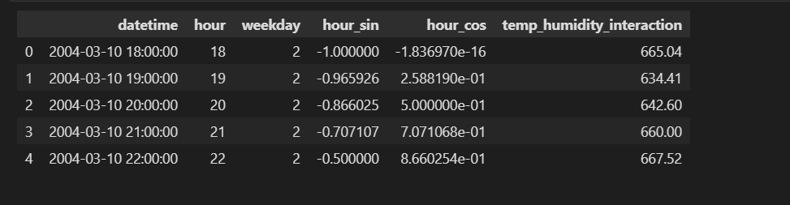

- References:

Air Quality Dataset Sources and Environmental Monitoring Data
Scikit-learn Documentation

Python Data Science Libraries:
- Pandas
- NumPy
- Matplotlib
- Seaborn

Research Papers on Air Quality Prediction using Machine Learning

Feature Engineering Techniques for Time-Series Forecasting

Machine Learning Regression Model Documentation

